**ASSIGNMENT-26.6:**

1.) Explain the difference between Static and Dynamic Partitioning in Hive with an example.

Static Partitioning:

Partitioning done with known fields is called as the static partitioning. We statically mention what partition has to be entered in to that partition. Static Partition saves your time in loading data compared to dynamic partition. “Statically” adding a partition in table and move the file into the partition of the table. This takes part of the database and stores into a file. Static partition is in Strict Mode.

Dynamic Partition:

Here no specific condition is given. Only the field is mentioned and the partition and the files are formed for each of the distinct entries. For Dynamic partition we have to we have to set dynamic partition as non-strict.

2.) Use static partitioning in hive and evaluate the below problem statements –

a) Find the number of medals India won year wise

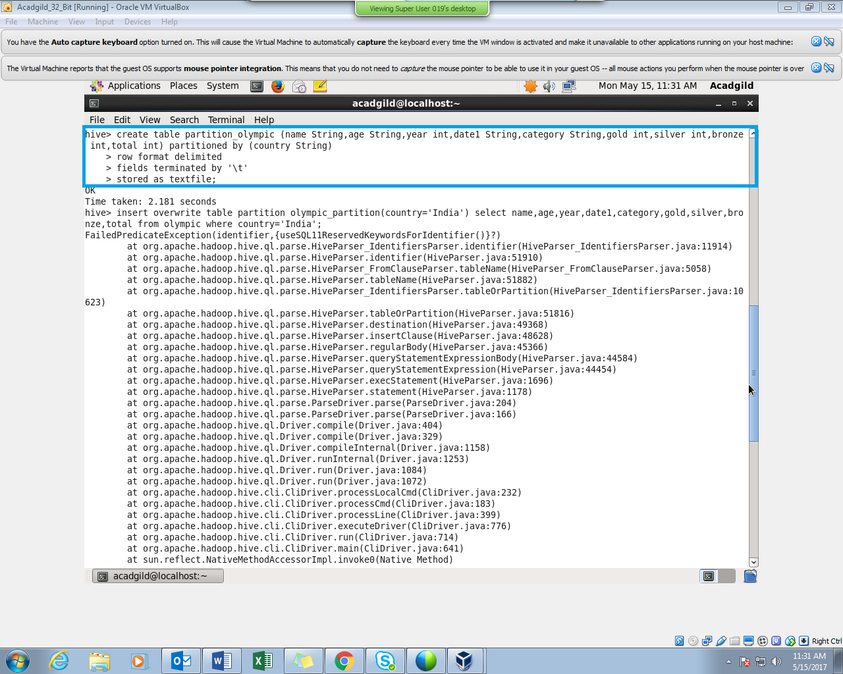

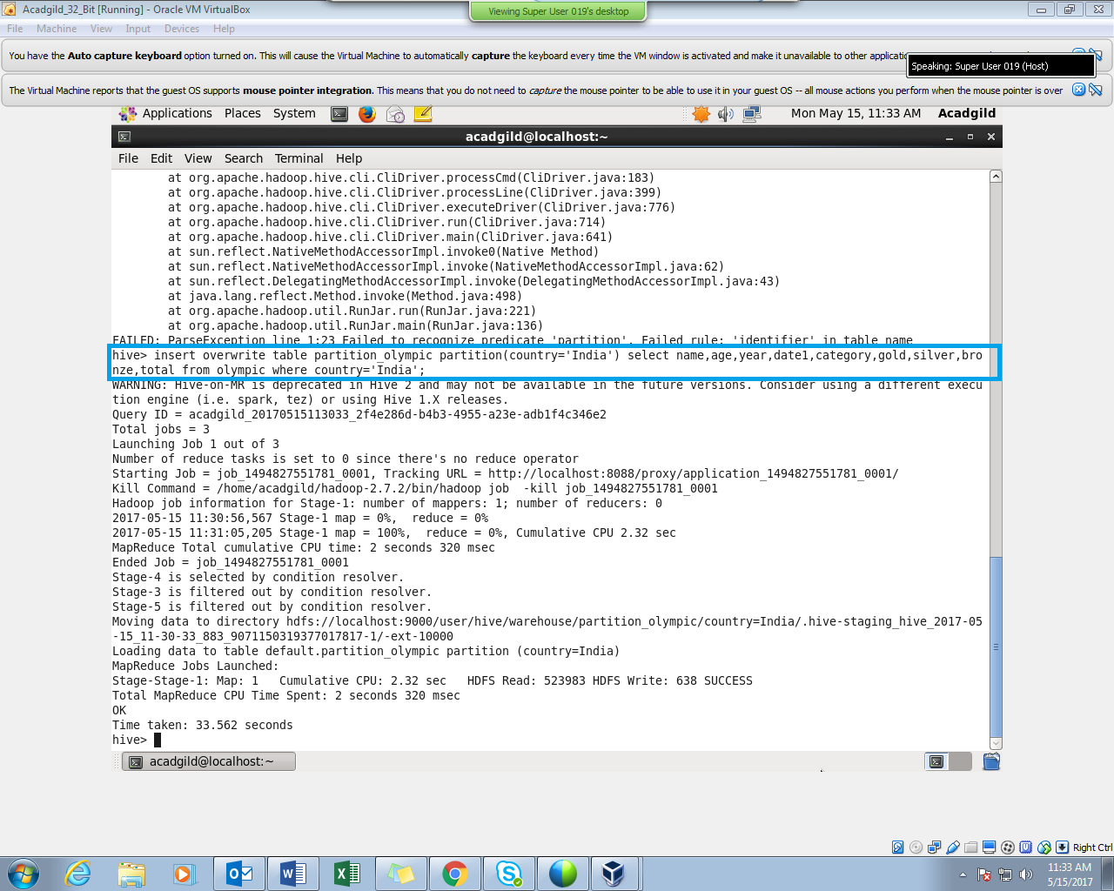

The total number of medals won by india year wise is displayed below.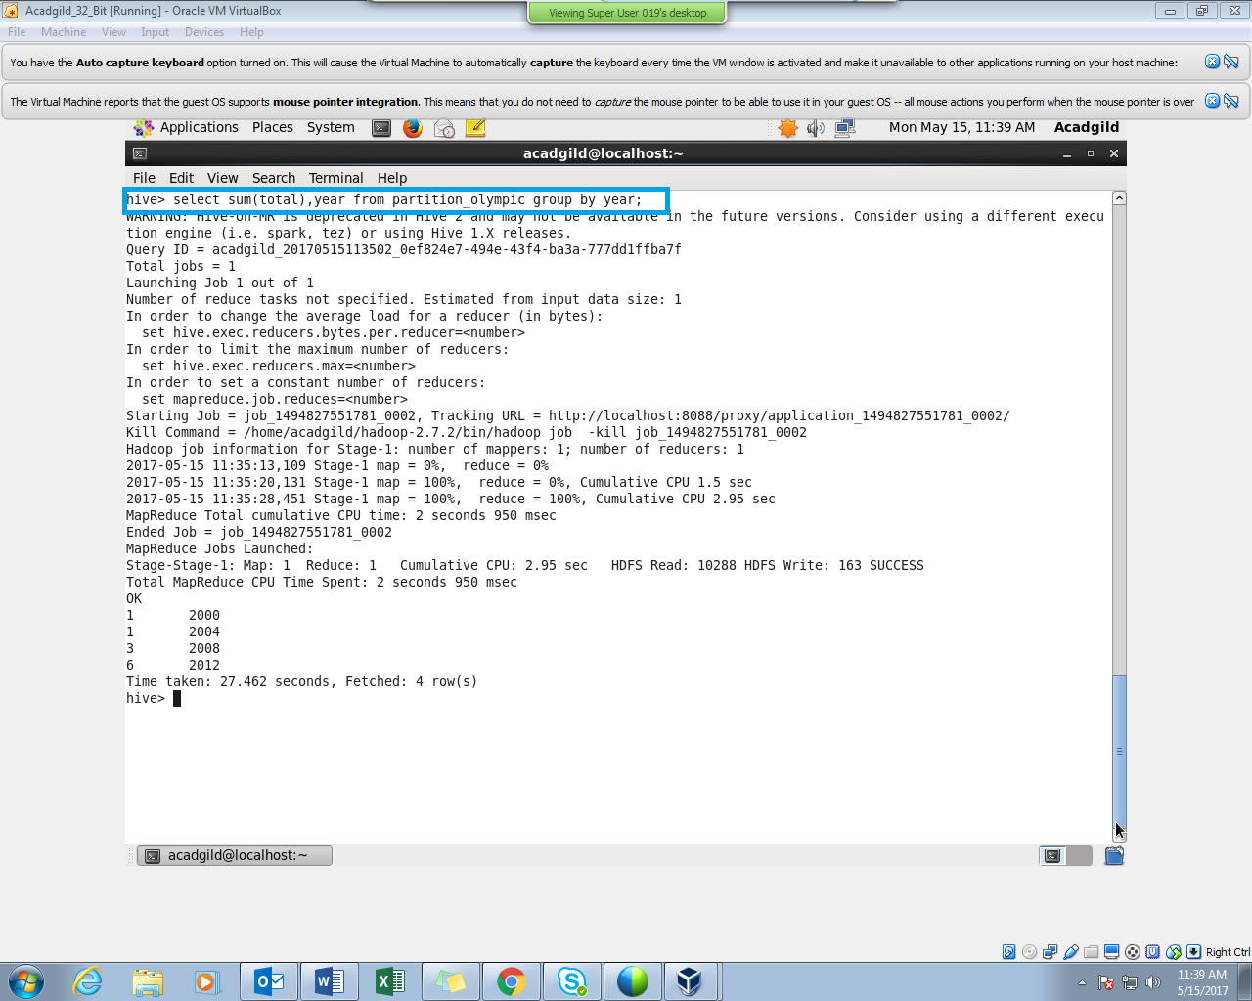

b) Find the number of medals india won in swimming year wise

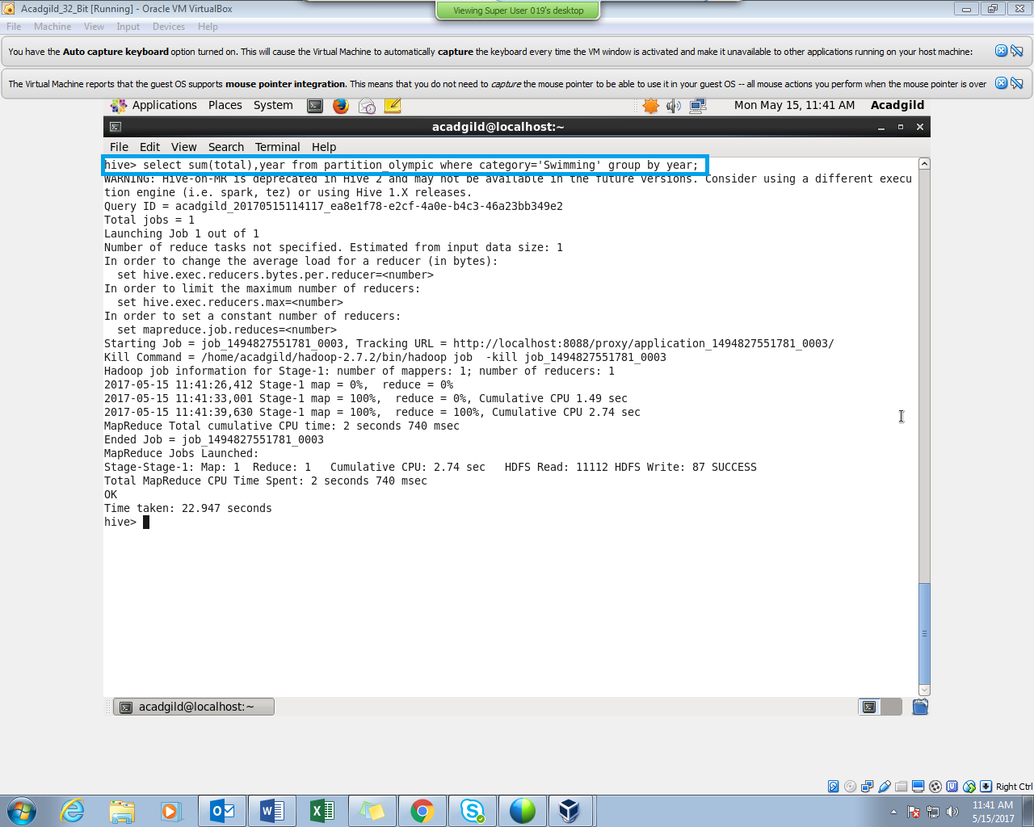

The above screenshot has no output, because India has not won any medal in swimming.

c) Find the number of gold and silver medals India won year wise

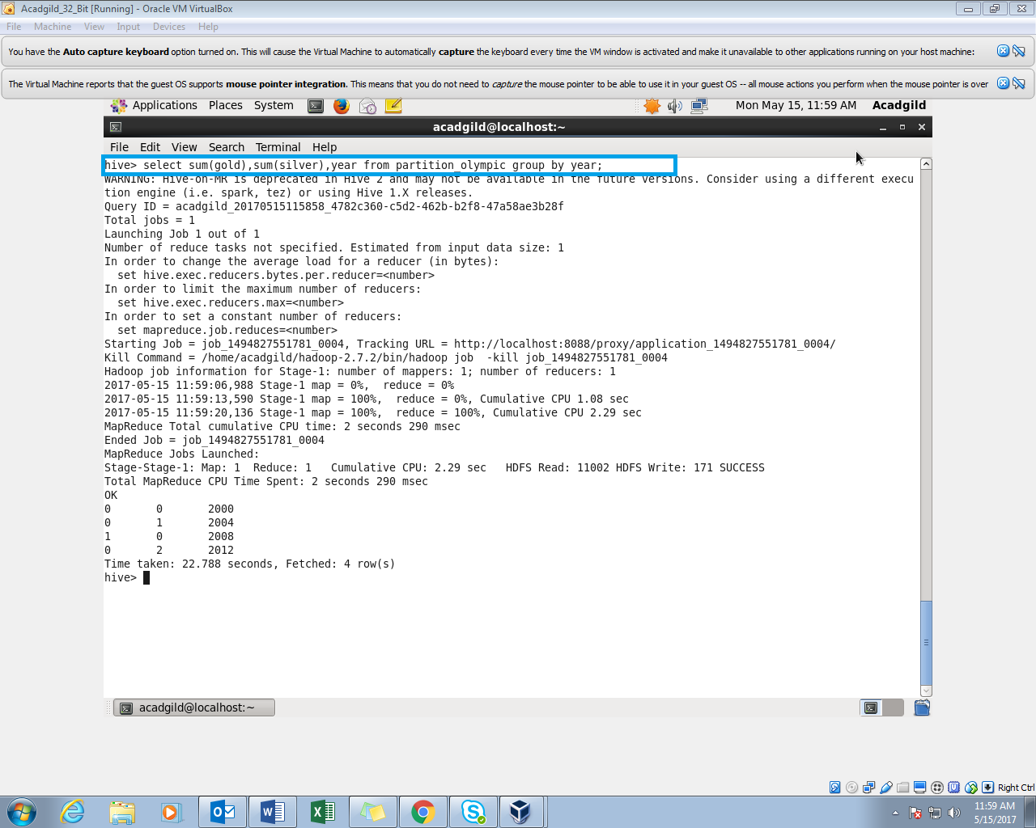

3. Use dynamic partitioning in hive and evaluate the below problem statements - Find the total number of medals won by each country.

Setting the dynamic partitions.

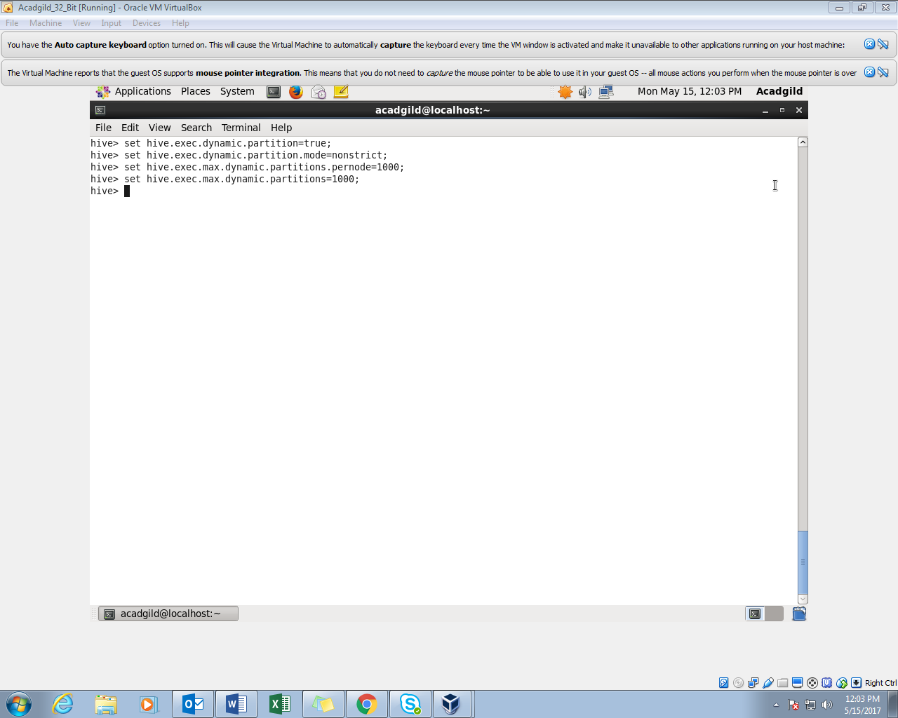

a)a

AsasaaSelecting the country and the no of medals won by each country.

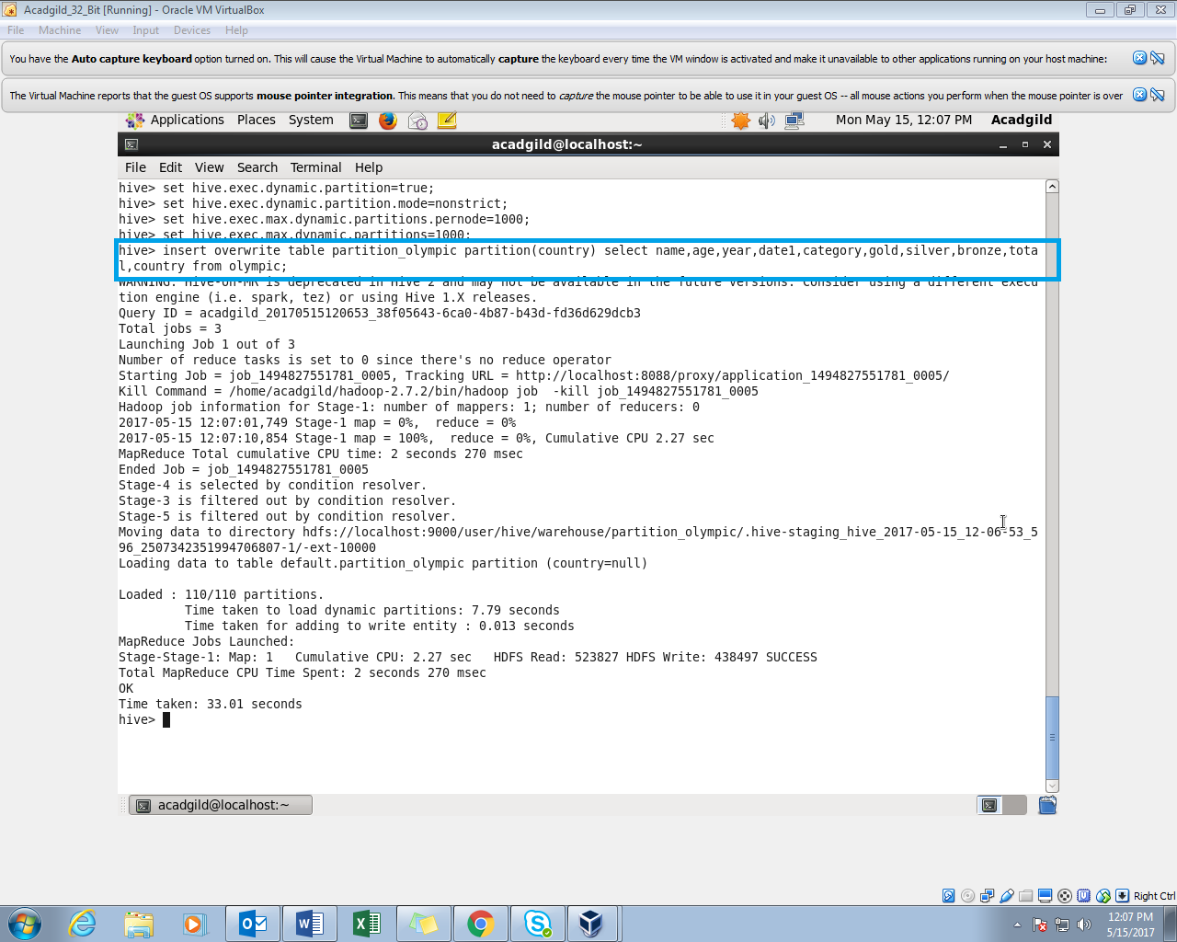

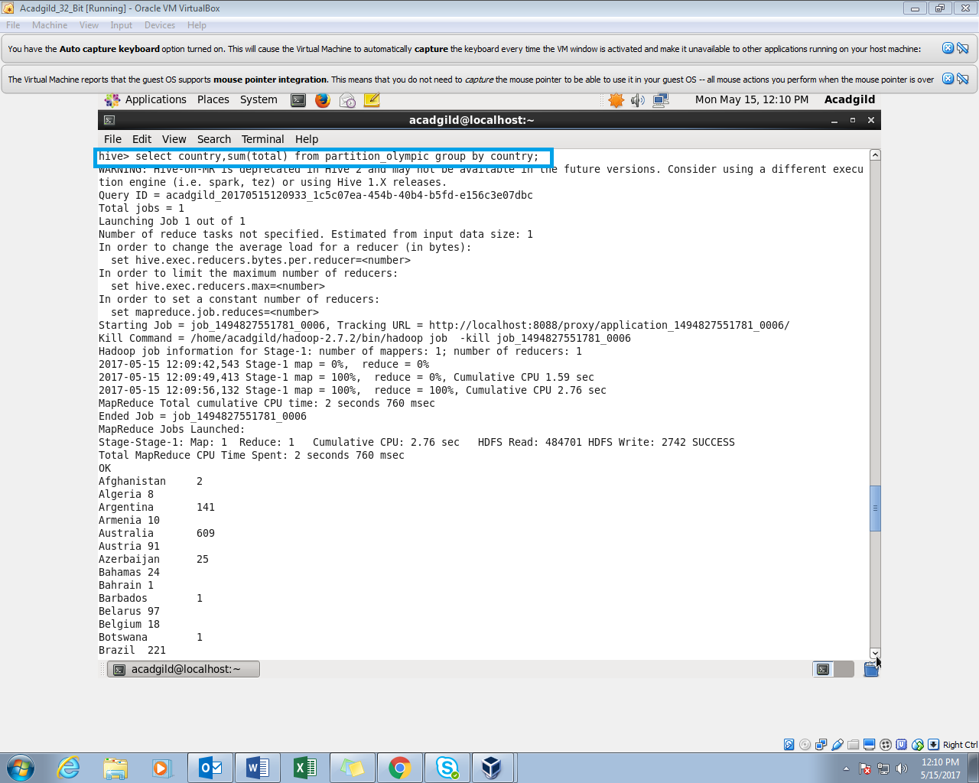

Output: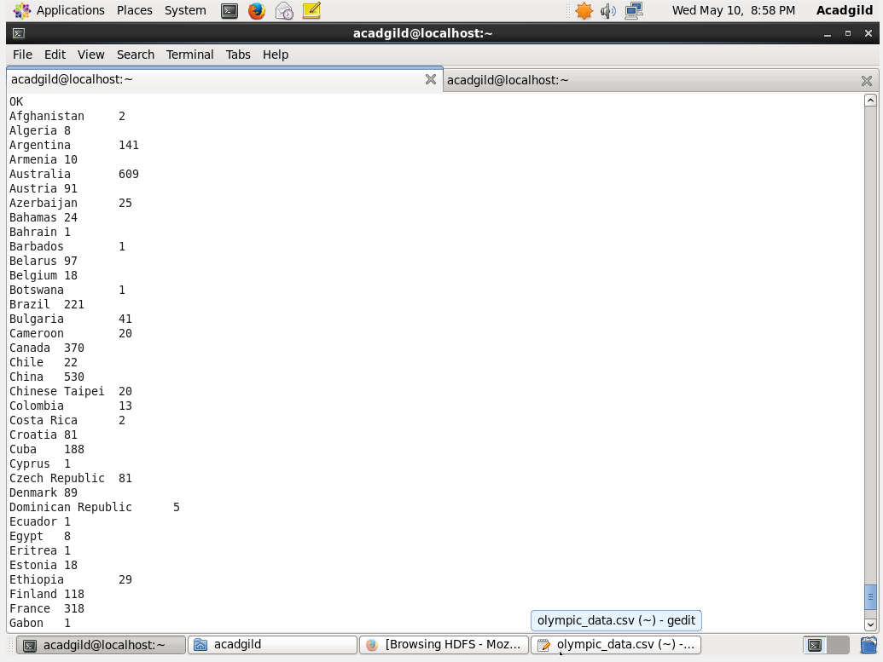

b) Find the number of medals each country won in Athletics year wise

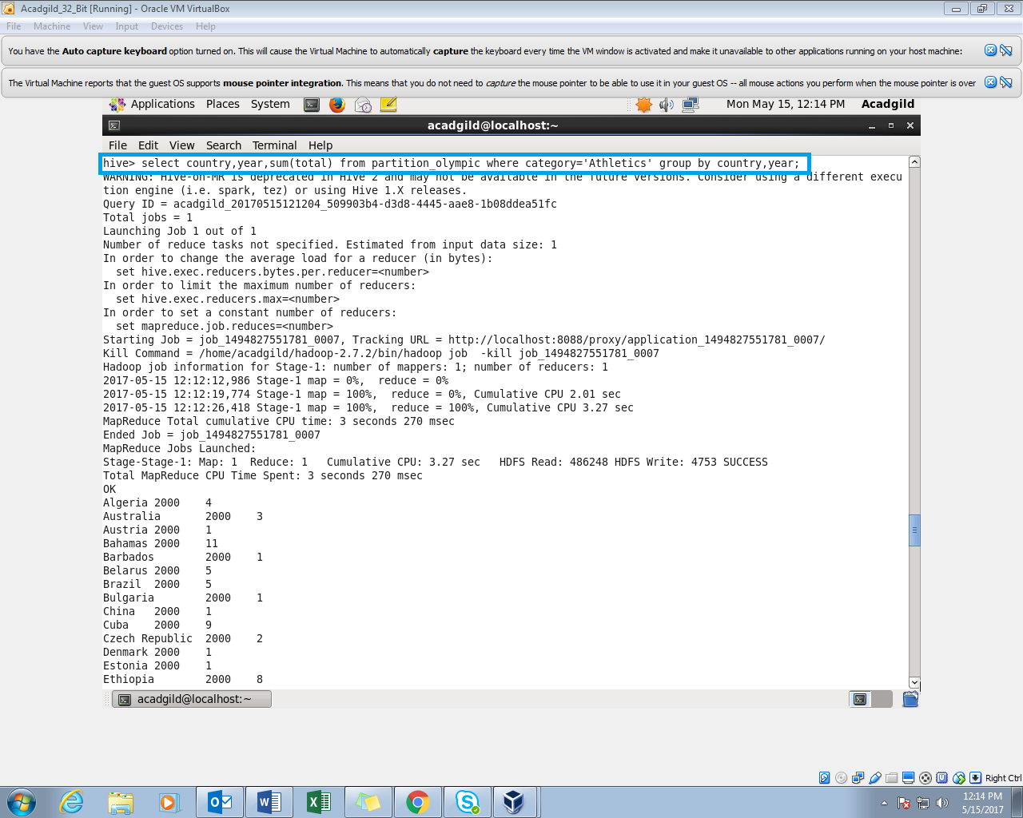

Output: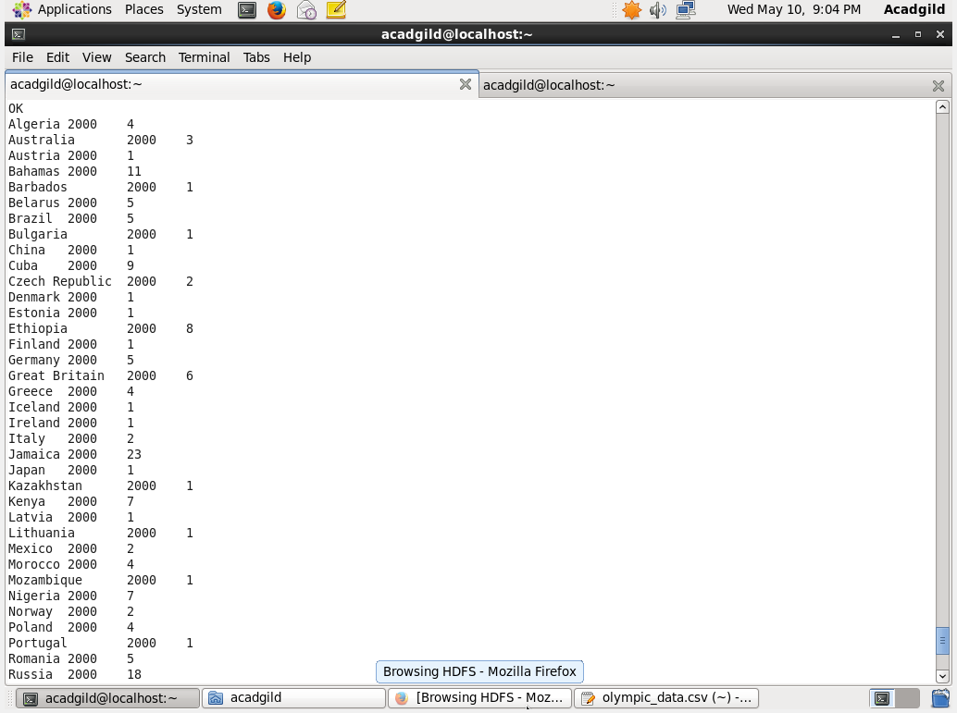

c) Find the average age of atheltes participated from each country in olympics year wise

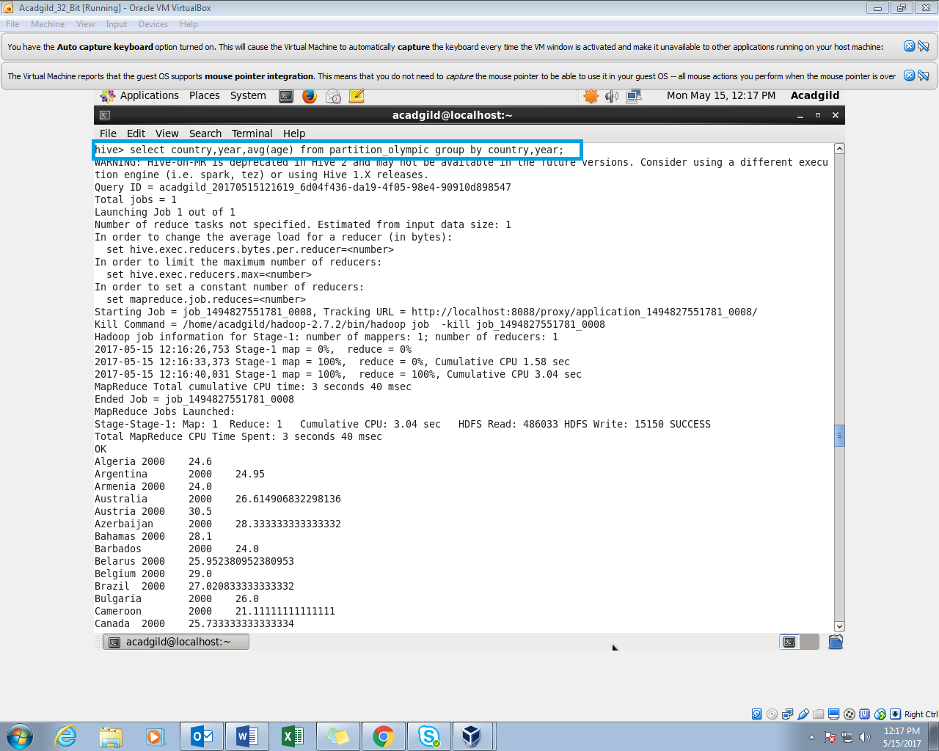

Output:

